Unleashing Energy Trends with Feature Insights
Shivansh Bansal¹[0009-0000-7253-6785],Rashmeet Kaur²[0009-0009-3303-5502] , Amita Goel³[0009-0002-2208-6530] ,Nidhi Sengar⁴[0000-0002-7154-2750] , and Vasudha Bahl⁵[0000-0002-7292-6000]
¹ Maharaja Agrasen Institute of Technology, Plot No 1, CH Bhim Singh Nambardar Marg, Sector- 22, PSP Area, Delhi- 110086
sbansal.official@gmail.com
² Maharaja Agrasen Institute of Technology, Plot No 1, CH Bhim Singh Nambardar Marg, Sector- 22, PSP Area, Delhi- 110086
kaurrashmeet680@gmail.com
³ Maharaja Agrasen Institute of Technology, Plot No 1, CH Bhim Singh Nambardar Marg, Sector- 22, PSP Area, Delhi- 110086
amitagoel@mait.ac.in
⁴ Maharaja Agrasen Institute of Technology, Plot No 1, CH Bhim Singh Nambardar Marg, Sector- 22, PSP Area, Delhi- 110086
nidhisengar@mait.ac.in
⁵ Maharaja Agrasen Institute of Technology, Plot No 1, CH Bhim Singh Nambardar Marg, Sector- 22, PSP Area, Delhi- 110086
vasudhabahl@mait.ac.in

Abstract. — In an era marked by escalating energy demand, accurate prediction of power consumption trends is paramount for ensuring efficient resource utilization and robust infrastructure planning [2]. This research endeavours to unveil insights into energy consumption patterns through the nuanced analysis of time series data. Leveraging advanced AI algorithms—XGBoost, LightGBM, CatBoost, and a Random Forest model—the study delves into hourly energy consumption pattern estimation [3][4][5]. Beginning with exploratory data analysis, the research seamlessly transitions into model development, utilizing hyperparameter tuning and cross-validation to optimize performance metrics such as root mean squared error (RMSE) and robustness.

The study culminates in a qualitative comparison of the models' robustness and runtime, shedding light on their effectiveness in capturing and predicting energy consumption patterns. LightGBM emerges as a standout performer, demonstrating not only high predictive accuracy but also swift execution. Feature significance analysis underscores the role of temporal features, unveiling the influence of factors such as the hour of the day, day of the week, and month on energy consumption [6].

Keywords: Energy Forecasting, AI Models, Boosted Algorithms, Data Exploration, Cross-Validation, Predictive Analysis

- Introduction
In the ever-evolving landscape of power systems, the accurate forecasting of electricity demand stands as a linchpin for effective grid planning and operations [11]. As modern societies continue to witness an unprecedented surge in energy consumption, the need for precise predictions has become paramount. Electricity demand forecasting serves as the cornerstone for utilities and grid operators, providing invaluable insights into anticipated load patterns, facilitating optimal resource allocation, and bolstering the overall reliability and resilience of the power grid. This research embarks on a comprehensive exploration of the intricacies involved in forecasting hourly electricity demand, addressing the challenges posed by the dynamic nature of energy consumption patterns.Subsequent paragraphs, however, are indented.
The forecasting of electricity demand presents a quintessential time series problem, where historical consumption data unfolds as a temporal sequence of observations. In this context, the efficacy of traditional statistical models is often eclipsed by the versatility and predictive power of machine learning models, particularly those rooted in tree-based methodologies. Leveraging the prowess of XGBoost, CatBoost, LightGBM, and Random Forest, this research endeavors to harness the collective strengths of these state-of-the-art machine learning algorithms. The objective is twofold: to elucidate the advantages of employing tree-based models in capturing intricate temporal dependencies within the electricity demand time series data and to conduct a rigorous comparative analysis to discern the nuances in performance among XGBoost, CatBoost, LightGBM, and Random Forest. Through this exploration, our aim is to provide valuable insights that contribute to the advancement of methodologies in the domain of hourly electricity demand forecasting, offering a roadmap for the integration of cutting-edge machine learning techniques into the critical arena of grid planning and operations.

- Literature Review
Electricity demand forecasting is a critical aspect of energy management and grid operation, playing a pivotal role in ensuring efficient utilization of resources and maintaining grid stability. As technology advances, the integration of machine learning (ML) techniques has gained prominence in enhancing the accuracy and efficiency of demand forecasting models.

  - Time Series Analysis and Forecasting
Box, Jenkins, and Reinsel [6] laid the foundation for time series analysis, introducing methodologies for forecasting and control. This traditional statistical approach has been widely used in the energy sector. However, the need for more sophisticated and scalable models has us, as researchers to explore the capabilities of machine learning.

  - Machine Learning Models
Several ML models have demonstrated their effectiveness in electricity demand forecasting. Notably, Random Forests and XGBoost, as discussed by Sioshansi and Denholm [2] and Chen and Guestrin [3], respectively, have shown promise in capturing complex patterns inherent in demand data. These ensemble methods leverage the power of decision trees to improve prediction accuracy.
The LightGBM algorithm, introduced by Ke et al. [4], represents another advancement in gradient boosting techniques. Its highly efficient implementation makes it suitable for handling large datasets, a crucial aspect in the context of electricity demand forecasting.
CatBoost, introduced by Prokhorenkova et al. [5], addresses challenges related to categorical features in forecasting models. Its unbiased boosting approach and ability to handle categorical variables make it a valuable tool in scenarios where traditional models may fall short.

  - Time Series Forecasting in the Energy Sector
Raju and Dutt [7] conducted a comprehensive review of data science applications in the energy sector, highlighting the importance of data-driven approaches. They emphasize the potential of ML techniques in optimizing energy systems and improving decision-making processes.

  - Statistical Tests and Assumptions
Shapiro and Wilk [9] proposed a test for normality, which has implications for the assumptions made in forecasting models. Royston [10] introduced an approximation to the Shapiro–Wilk test, facilitating its application in various scenarios.

  - Review Articles in Electricity Demand Forecasting
Several review articles provide a comprehensive overview of the state-of-the-art methods in electricity demand forecasting. Hong et al. [11], Amjady and Keynia [12], and Zhang and Lin [14] offer insights into different forecasting methodologies and their applications. Makridakis et al. [15] and Misra et al. [16] specifically focus on short-term load forecasting using data-driven methods.

  - Electricity Grid and Fault Detection
Raza et al. [13] delve into the application of time series data mining techniques for the detection of smart grid faults. This highlights the broader scope of machine learning in ensuring grid reliability and security.
In conclusion, the integration of machine learning techniques in electricity demand forecasting has emerged as a promising avenue for researchers. These models not only outperform traditional statistical approaches but also offer scalability and flexibility, making them well-suited for the evolving landscape of energy systems. As technology continues to advance, the synergy between machine learning and demand forecasting is likely to play a pivotal role in shaping the future of energy management.

- Methodology

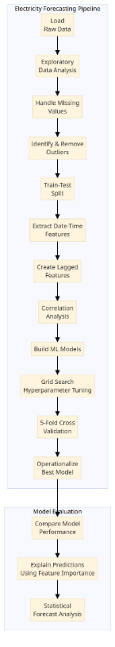
Fig. 1. Flowchart of methodology

  - Normality Testing of the Dataset
Normality testing is a factual methodology used to decide if a dataset follows an ordinary dispersion. With regards to energy utilization patterns expectation, evaluating the ordinariness of the dataset is urgent for coming to educated conclusions about the decision regarding measurable techniques and models. There are different measurable tests accessible for ordinariness testing, and one normal methodology is the Shapiro-Wilk test.
The Shapiro-Wilk test is one such strategy, and it's generally utilized for little to reasonably estimated datasets. The invalid speculation of this test is that the information follows a typical dissemination.
This is the way we played out the Shapiro-Wilk test and portray it alongside numerical conditions:

Presently, we separate the parts of the Shapiro-Wilk test:

Null Speculation (H0). The invalid speculation expects that the information follows an ordinary circulation.

Alternative Speculation (H1). The elective theory recommends that the information doesn't follow a typical conveyance.

Test Measurement (W). The Shapiro-Wilk test measurement (W) is determined from the noticed information and is utilized to evaluate how well the information fits a typical circulation.

p-value. The p-esteem related with the test measurement demonstrates the likelihood of noticing the information on the off chance that the invalid speculation is valid. A little p-esteem (regularly not exactly the picked importance level, frequently 0.05) prompts the dismissal of the invalid speculation.
Numerically, the Shapiro-Wilk test measurement is processed utilizing the accompanying equation:

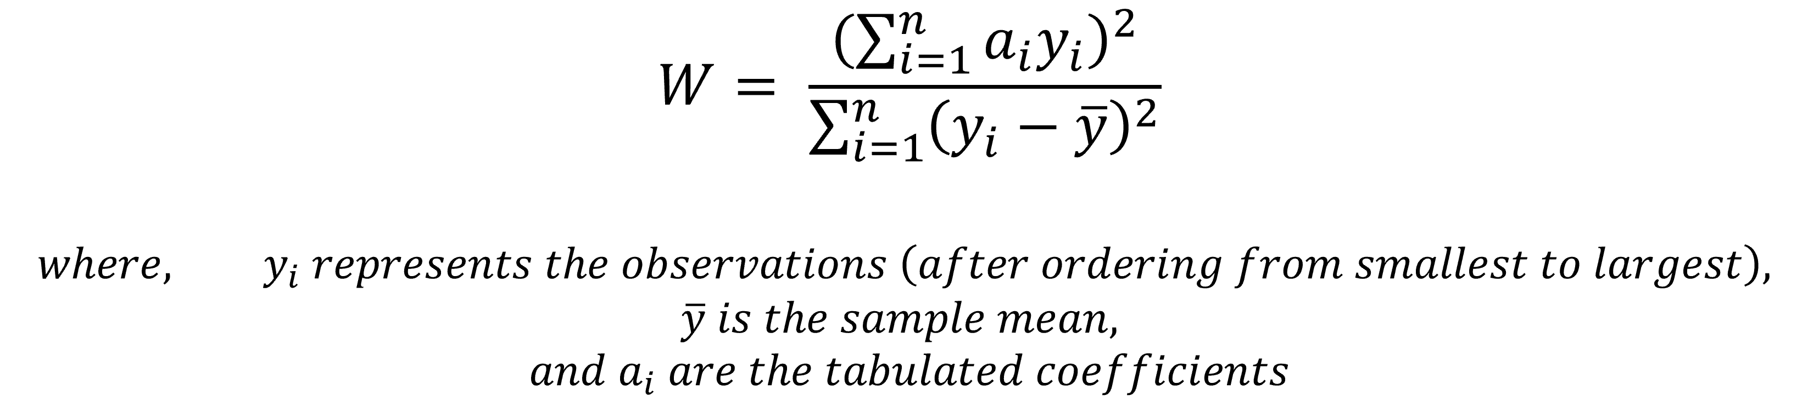
Fig. 1. Shapiro-Wilk Test

Dataset Normality Testing. To apply the Shapiro-Wilk test to your energy consumption dataset, we use Python's `scipy.stats.shapiro` function. Here's an example:
.
```python code
from scipy.stats import shapiro

# Assuming 'df' is your dataset and 'PJME_MW' is the column of interest
stat, p_value = shapiro(df['PJME_MW'])

# Interpret the results
alpha = 0.05
if p_value < alpha:
print("Reject the null hypothesis: Data does not follow a normal distribution.")
else:
print("Fail to reject the null hypothesis: Data may follow a normal distribution.")
```

This code snippet calculates the Shapiro-Wilk test statistic and its corresponding p-value for the 'PJME_MW' column in our dataset. We adjust the column name accordingly based on our dataset structure.
  - Data Preprocessing
Data preprocessing is a crucial phase in ensuring the quality and appropriateness of the dataset for subsequent machine learning modeling. In the context of this research project on hourly electricity demand forecasting, data preprocessing involves several key steps[15]. Missing values are handled using techniques such as imputation, and outliers are identified and addressed to prevent their influence on model performance. The temporal nature of the data requires encoding features appropriately, often involving the conversion of datetime objects or categorical variables into numerical representations. Additionally, normalization techniques like Min-Max scaling are applied to ensure that all features contribute uniformly to the model training process. The process of data preprocessing is integral to achieving a standardized and coherent dataset, laying the foundation for accurate model development and evaluation.
  - Data Visualization
Based on the code and visualizations in the project, here is a description of some of the key data visualizations and analysis:

Time Series Plot.
. 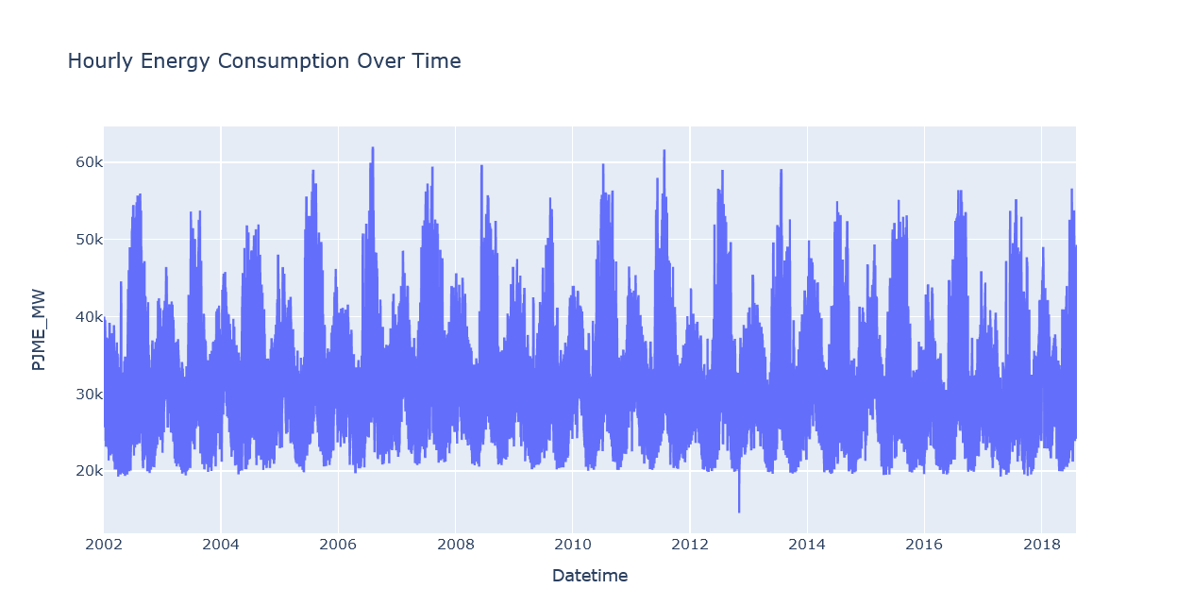
Fig. 3. A basic time series plot of the energy consumption data over time

This plots the PJME_MW variable over time, showing the general trends and seasonality.

Distribution Plot.
. 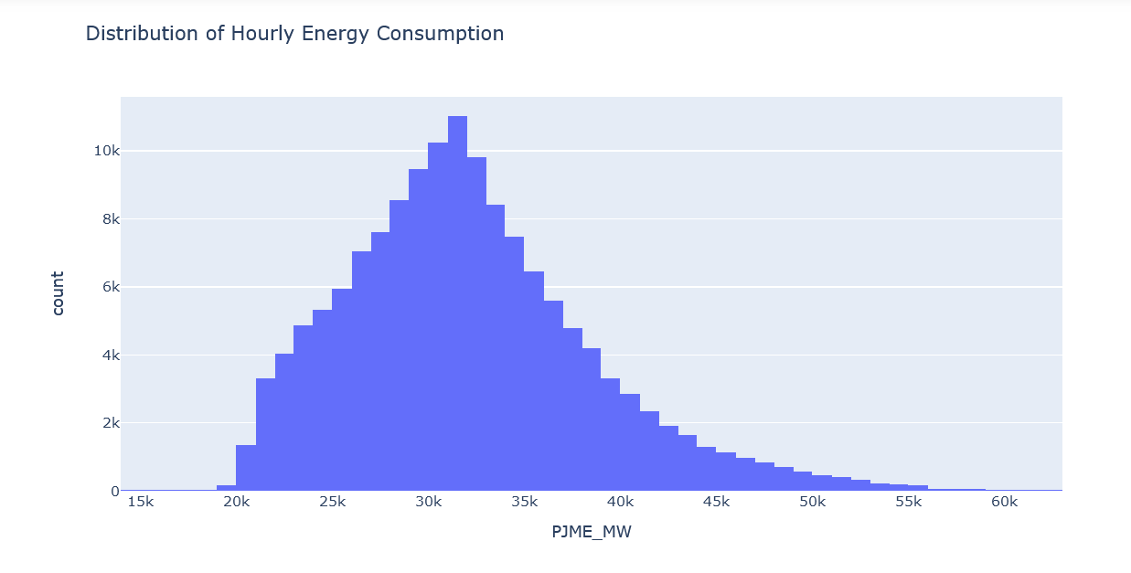
Fig. 4. A histogram showing the distribution of the energy consumption data

This shows the frequency of different consumption values:

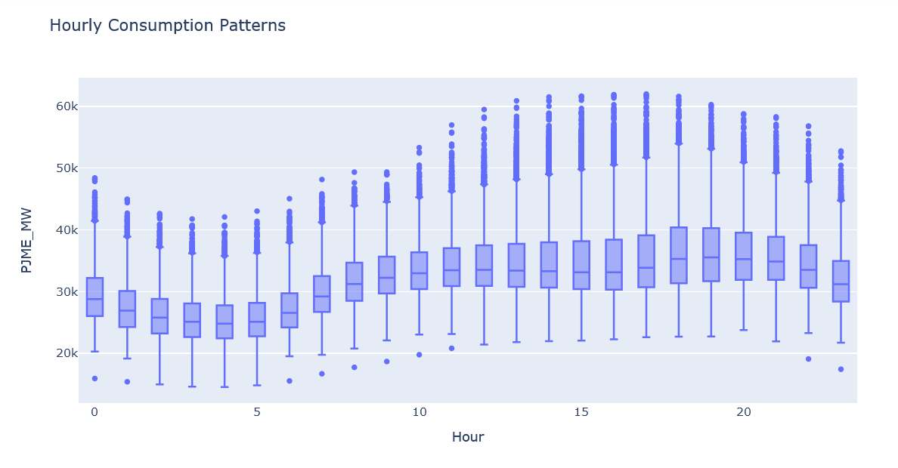

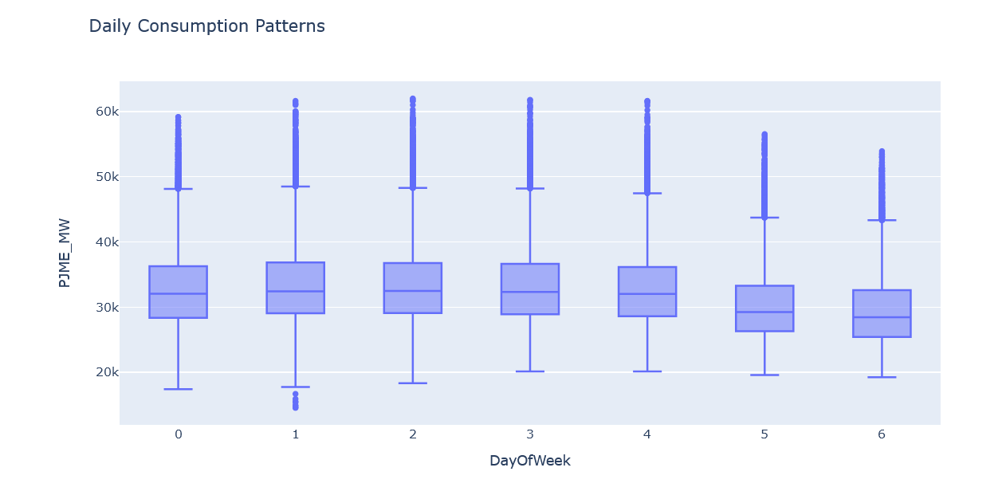

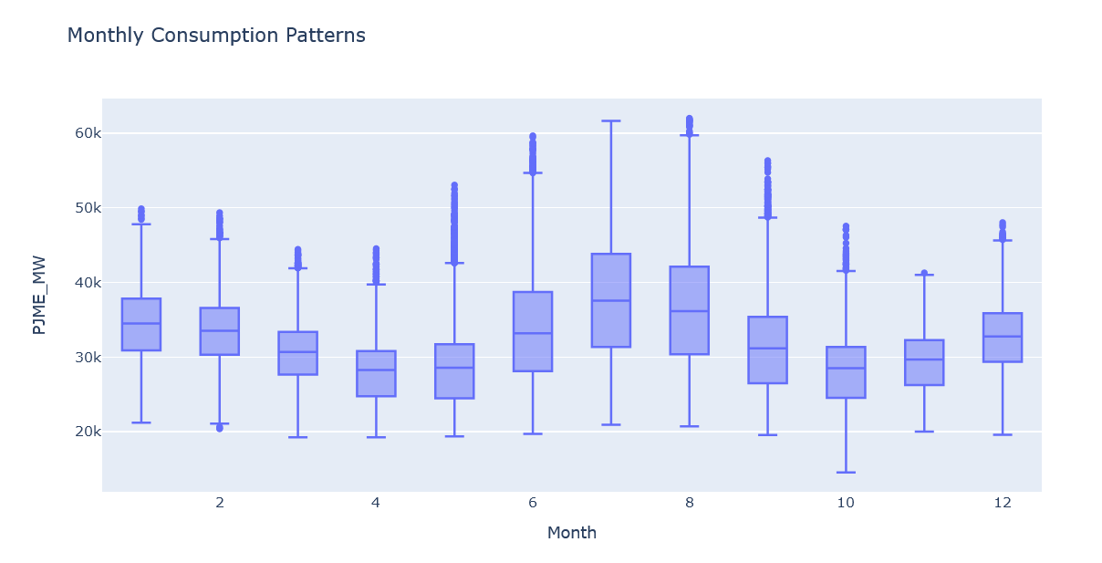

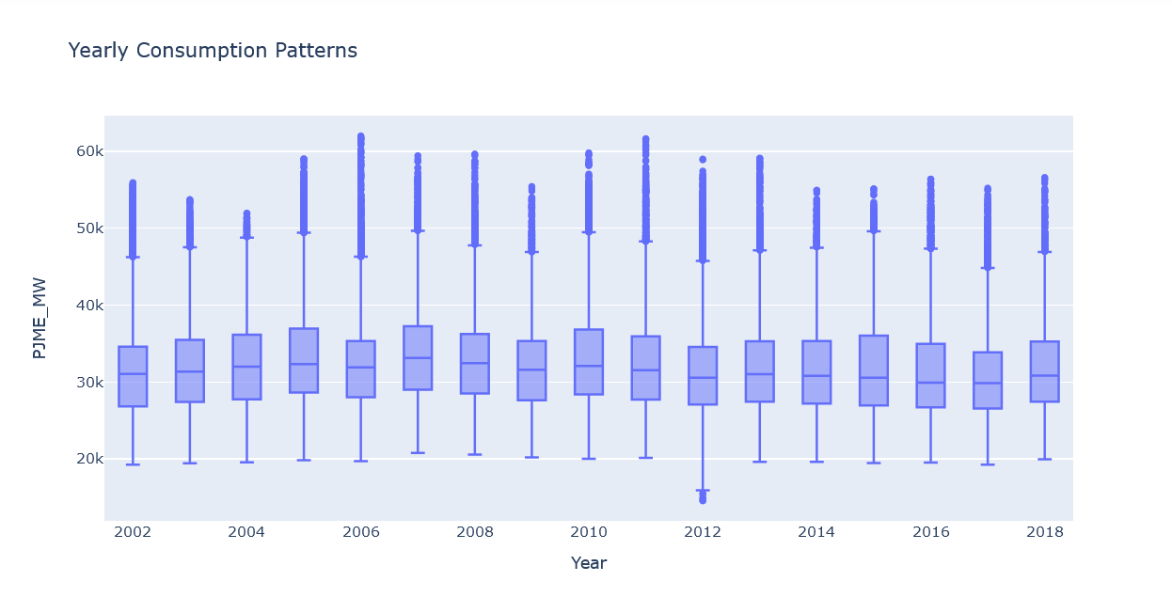

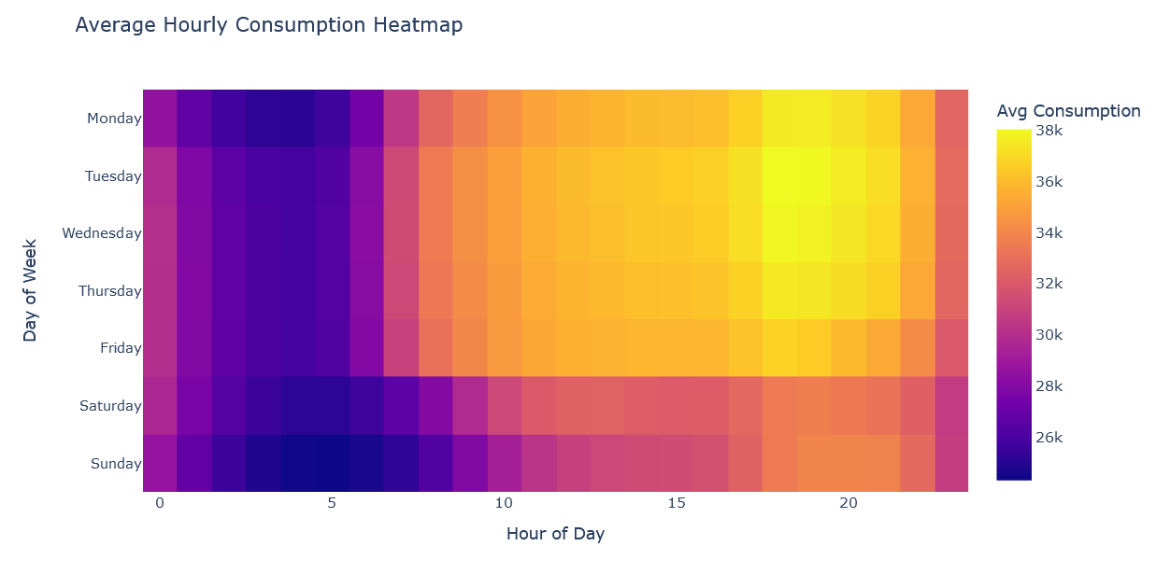
Fig. 5. Consumption Patterns

Lag Plot.
.
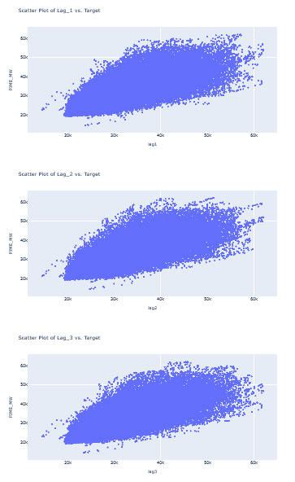
Fig. 6. A scatter plot of the target variable versus lagged values

This shows the relationship between past consumption and current consumption.

Seasonal Decomposition Plot.
.
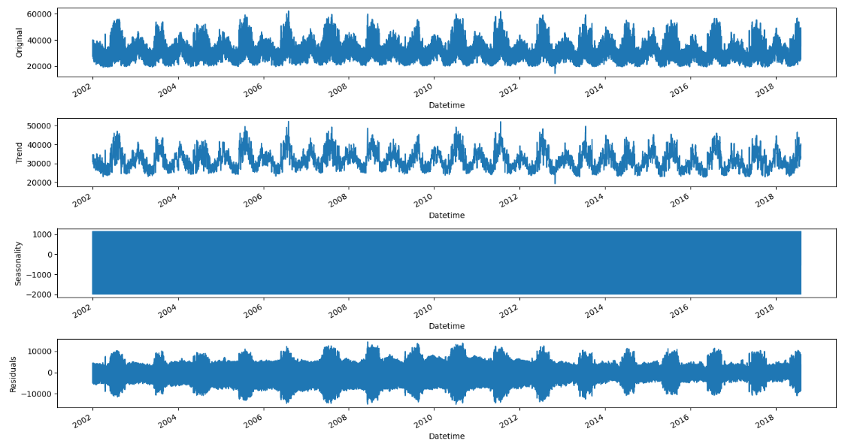
Fig. 7. Decomposes the time series into trend, seasonal, and residual components
Model Development Using Machine Learning. In the model development phase, four distinct machine learning models are employed for hourly electricity demand forecasting: XGBoost Regression, CatBoost Regression, LightGBM Regression, and Random Forest Regression.

XGBoost Regression. XGBoost, an ensemble learning algorithm, stands as a robust tool for regression tasks in electricity demand forecasting [11].Operating on the principle of boosting, XGBoost sequentially constructs a series of decision trees to minimize the residuals. The model's prediction is a weighted sum of these trees, showcasing its adaptability in capturing intricate relationships within the data. One of XGBoost's notable features is its introduction of regularization terms in the objective function, effectively controlling overfitting and ensuring efficiency in handling large datasets. The objective function for XGBoost is defined as follows:
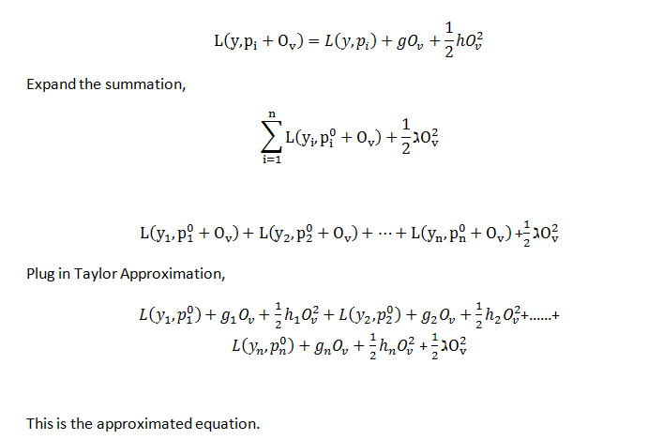
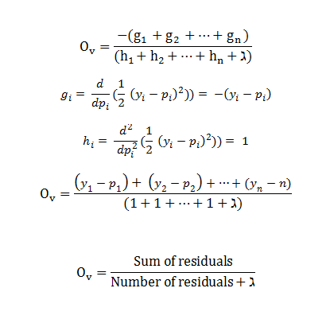
Fig. 8. Formula for XGBoost Regression
CatBoost Regression. CatBoost [13], designed specifically for categorical feature support, stands out in scenarios where traditional machine learning models might struggle with categorical variables [13]. In the context of electricity demand forecasting, where categorical features like day of the week or holiday indicators can significantly impact consumption patterns, CatBoost becomes particularly relevant [13]. Its prediction follows the same fundamental principle as XGBoost, relying on a combination of decision trees. The unique feature of CatBoost lies in its ability to handle categorical features naturally without requiring explicit preprocessing [13].

LightGBM Regression. LightGBM, another gradient boosting framework, adopts a different tree growth strategy, emphasizing leaf-wise growth to enhance computational efficiency [13]. Its prediction is expressed mathematically as the sum of weighted leaf values, allowing LightGBM to handle large datasets with higher speed and efficiency compared to traditional depth-wise growth methods. Its adaptability to parallel processing makes it well-suited for scalable applications in electricity demand forecasting. The LightGBM objective function is similar to XGBoost and CatBoost, with additional terms for leaf-wise growth.
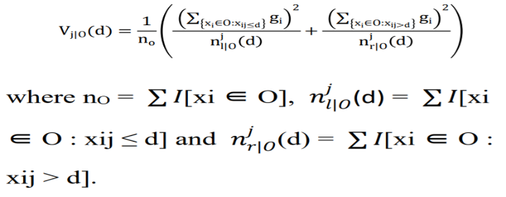
Fig. 9. Formula for LightGBM Regression

Random Forest. Random Forest [15] is a powerful ensemble machine learning model that excels in predictive tasks, leveraging the collective strength of multiple decision trees [15]. Employing a technique known as bagging, it constructs a diverse set of trees by training each on a random subset of the data, coupled with feature randomization during the splitting process. This ensemble approach enhances predictive accuracy, mitigates overfitting, and provides resilience to outliers and noisy data. Notably, Random Forest automatically performs feature selection by assessing the importance of each feature across the ensemble, making it a versatile and widely applicable model in both classification and regression tasks across various domains [15].

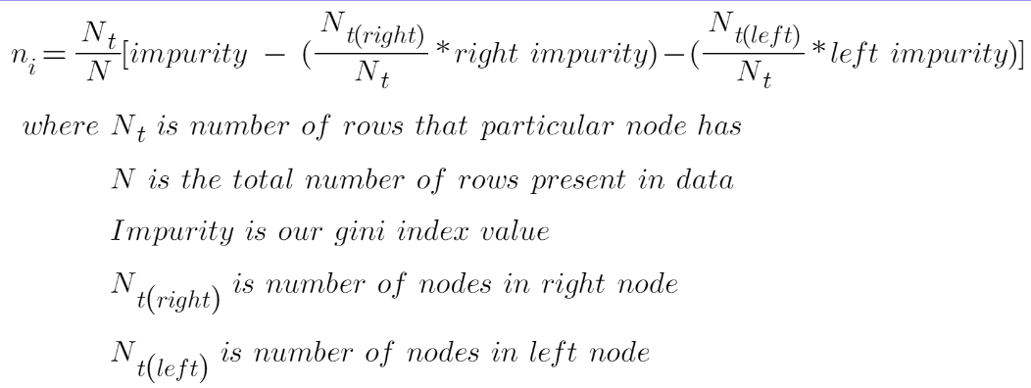
Fig. 10. Formula for Random Forest

Feature Analysis:
Transforms the datetime index into useful time and date features:

```
def create_features(df):
df['hour'] = df.index.hour
df['dayofweek'] = df.index.dayofweek
df['quarter'] = df.index.quarter
df['month'] = df.index.month
df['year'] = df.index.year
Table 1- Differences among the 4 models

df['dayofyear'] = df.index.dayofyear
return df
```

This extracts hour, day of week, quarter, month, year, and day of year as features.

Feature Correlation Analysis. Examines correlations between all features:
```
corr = df.corr()
sns.heatmap(corr, annot=True, cmap='coolwarm')
```

Lag Feature Analysis. Adds lagged values of the target as features:
```
def add_lags(df):
df['lag1'] = df['PJME_MW'].shift(24)
df['lag2'] = df['PJME_MW'].shift(48)
return df
```
This includes past energy usage values to help prediction.

Feature Importance Analysis. Quantifies predictive value of each feature:

```
fi = pd.DataFrame(data=best_reg.feature_importances_,
index=best_reg.feature_names_in_,
columns=['importance'])
```

Shows the model-based ranking of what input features are most useful for predicting the target.
So in summary, it extracts intelligently-designed features, examines relationships between features, and evaluates the predictive utility of features based on model feedback.

- Result & Analysis
  - Model Development and Performance
In the project titled "Predicting Energy Consumption Trends: Feature Importance Analysis," advanced AI algorithms, including XGBoost, LightGBM, CatBoost, and an additional Random Forest model, were implemented to estimate hourly energy consumption patterns [3][4][5]. Rigorous hyperparameter tuning and time series cross-validation were employed to enhance the performance of these models. The selected models demonstrated competitive performance in capturing and predicting energy consumption patterns, with the robustness and root mean square error (RMSE) used as the evaluation metrics.

Table 1. QUANTITATIVE COMPARISON OF THE MODELS

Model | RMSE | Comparison
XGBoost | 3519.7911 | Worse
LightGBM | 3150.722 | Best
CatBoost | 3265.607 | Better
RandomForest | 3491.4575 | Worse

Table 2. QUALITATIVE COMPARISON OF THE MODELS
Model | Time to Run | Robustness
LightGBM | 1 m 37s | High
XGBoost | 1 m 49s | High
CatBoost | 4 m 39s | High
Random Forest | 9 m 31s | Moderate

The table above summarizes the time taken for each regression model to run and provides a qualitative assessment of their robustness. LightGBM and XGBoost exhibited high robustness with relatively shorter runtimes, while CatBoost, despite a longer runtime, maintained high robustness. Random Forest, while taking the longest time to run, demonstrated moderate robustness.

  - Feature Significance Analysis
Feature engineering played a crucial role in improving model performance, with lagged features and time-related attributes contributing significantly. Exploratory data analysis (EDA) underscored the importance of temporal features such as hour of the day, day of the week, and month in influencing energy consumption [6]. Feature significance analysis highlighted the vital role of these temporal features in predicting energy usage patterns [3][4][5].

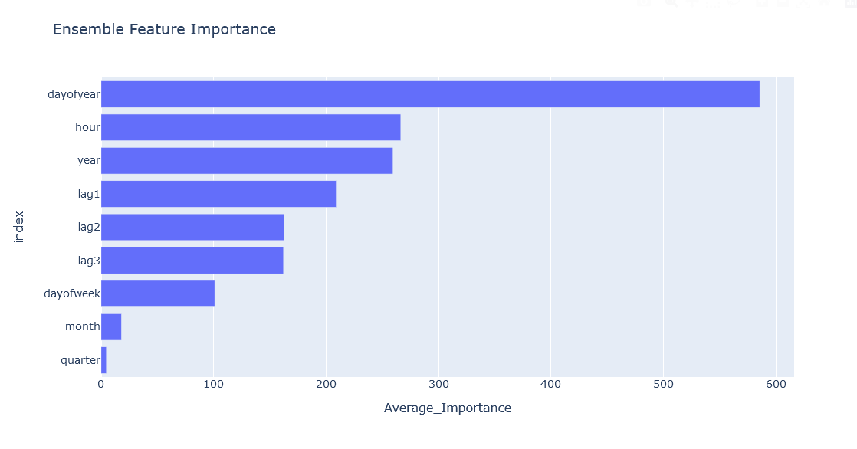
Fig. 11. Feature Importance Analysis
  - Future Prediction Visualization
The figure below illustrates the future prediction component of the project. It involves creating features, adding lagged features, and xutilizing an XGBRegressor for prediction. The resulting predictions for future timestamps are visualized using a line plot, providing a glimpse into the projected energy consumption patterns beyond historical data.

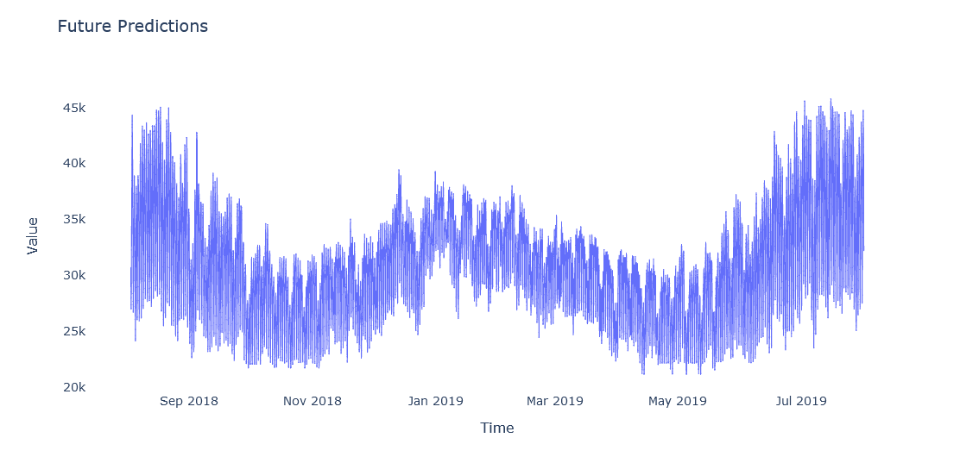
Fig. 12. Future Prediction Visualization

In conclusion, the findings of this research hold significant implications for policymakers, energy planners, and researchers in making informed decisions related to energy resource allocation and infrastructure planning. The comprehensive analysis of feature importance and the successful application of advanced machine learning models demonstrate the potential of these approaches in shaping sustainable and efficient energy usage.

- CONCLUSION & FUTURE SCOPE
In conclusion, this research provides a comprehensive examination of hourly electricity demand forecasting, emphasizing the efficacy of tree-based machine learning models. The comparative analysis highlights the superior performance of LightGBM, emerging as the fastest model with an execution time of 1 minute and 37 seconds. Its efficiency in processing data, coupled with robust predictive accuracy, positions LightGBM as an optimal choice for hourly electricity demand forecasting. Additionally, LightGBM excels in feature analysis, providing valuable insights into the most influential factors affecting electricity demand.
The adaptability of machine learning algorithms, particularly evident in extracting intricate patterns without extensive manual feature engineering, signifies a significant advancement in the field. Notably, the capability of these models to handle categorical features positions them as valuable tools for grid planning and operational decision-making.
Practical implications of this research are substantial, with the integration of LightGBM offering enhanced predictive accuracy and a solid foundation for informed decision-making in grid planning and operations. By providing reliable insights into anticipated load patterns, these models facilitate optimal resource allocation, contributing to the overall resilience and efficiency of the power grid.
In the course of this study, it was determined that the most influential feature impacting electricity demand is ‘day of the year.’ This insight not only enhances our understanding of demand drivers but also underscores the importance of this variable in shaping future forecasting models.
Looking ahead, the future scope of this project extends to several exciting possibilities. Firstly, exploring ensemble methods that combine the strengths of multiple models could further enhance predictive accuracy. Secondly, incorporating external factors such as weather patterns or socioeconomic indicators may provide a more holistic understanding of electricity demand dynamics. Lastly, the integration of real-time data streams and continual model updates can ensure adaptability to evolving energy consumption patterns.
In essence, the integration of tree-based machine learning models in hourly electricity demand forecasting not only enhances predictive accuracy but also establishes a framework for resilient and efficient grid planning and operations. As the landscape of power systems evolves, leveraging the strengths of these models promises a trajectory toward a more reliable, resilient, and efficient power grid.
- LIMITATIONS
Limited data sample: The study likely utilized a limited electricity consumption dataset from a specific regional grid or utility provider. Results may not generalize to other geographic areas or grid systems. Expanding the dataset could improve generalizability.
Assumptions of machine learning models: The machine learning models rely on assumptions that may not perfectly hold for the data. For example, assuming consumption patterns are stationary when they may change over longer time periods. Discussing limitations of these assumptions provides transparency.
Lack of exogenous variables: The models mostly rely on historical electricity demand patterns. Incorporating exogenous data like weather could account for more demand fluctuation factors, improving accuracy.
Overfitting: Rigorous cross-validation procedures were followed but some amount of overfitting is still likely. The performance metrics represent in-sample rather than out-of-sample testing.
Simplifying assumptions: There are likely variables that influence consumption not included in the models (economic factors, demand-response policies etc.). The models simplify the very complex demand environment.
Practical challenges: Even accurate models may prove challenging to integrate into grid operations due to legacy systems and inertia to adopt data-driven methods. Practical limitations around model deployment should be acknowledged.

Acknowledgements
We would like to express our sincere gratitude to Dr. Amita Goel, Head of the Department for the Department of IT & Engineering, for her invaluable guidance and continuous support throughout the research process. Her expertise and encouragement significantly contributed to the success of this research project.
We are also thankful to Dr. Neelam Sharma, Director of Maharaja Agrasen Institute of Technology, Rohini, Delhi, for her unwavering support and encouragement. Her visionary leadership has been a source of inspiration.
Special appreciation goes to Ms. Nidhi Sengar and Dr. Vasundha Bahl from Maharaja Agrasen Institute of Technology for their substantial contributions and support during the course of this research. Their insights and assistance have greatly enriched the quality and depth of our work.
This research paper has been a collaborative effort, and we would like to acknowledge each other’s effort within the team. The combined efforts of the team have further elevated the quality and depth of this work.
Lastly, we extend our appreciation to all those who have supported us directly or indirectly during the course of this research. Your contributions have been invaluable.

References
- PJM Interconnection. (https://www.pjm.com/)
- Sioshansi, R., & Denholm, P. (2009). The value of plug-in hybrid electric vehicles as grid resources. *Energy Policy, 37*(11), 4595–4602.
- Chen, T., & Guestrin, C. (2016). XGBoost: A Scalable Tree Boosting System. In Proceedings of the 22nd ACM SIGKDD International Conference on Knowledge Discovery and Data Mining (KDD '16), 785–794. DOI: 10.1145/2939672.2939785
- Ke, G., Meng, Q., Finley, T., Wang, T., Chen, W., Ma, W., & Ye, Q. (2017). LightGBM: A Highly Efficient Gradient Boosting Decision Tree. Advances in Neural Information Processing Systems, 30.
- Prokhorenkova, L., Gusev, G., Vorobev, A., Dorogush, A. V., & Gulin, A. (2018). CatBoost: unbiased boosting with categorical features. Advances in Neural Information Processing Systems 31 (NeurIPS 2018).
- Box, G. E., Jenkins, G. M., & Reinsel, G. C. (2015). Time Series Analysis: Forecasting and Control. Wiley.
- Raju, K., & Dutt, V. (2019). Applications of data science in the energy sector: A review. *Renewable and Sustainable Energy Reviews, 101*, 591–609.
- Salmeron, J., & Wood, K. (2004). Optimal transmission switching. IEEE Transactions on Power Systems, 19*(3), 1323–1331.
- Shapiro, S. S., & Wilk, M. B. (1965). An analysis of variance test for normality (complete samples). Biometrika, 52(3/4), 591–611.
- Royston, J. P. (1992). Approximating the Shapiro–Wilk W-test for non-normality. Statistics and Computing, 2(3), 117–119.
- "Electricity demand forecasting: A review of state-of-the-art methods"
- Author(s): Hong T., Pinson P., Fan S.
- Published in: International Journal of Energy Research, 2016.
- "Short-term load forecasting using machine learning techniques: An overview and comparative analysis"
- Author(s): Amjady N., Keynia F.
- Published in: Electric Power Systems Research, 2013.
- "A review on time series data mining techniques for the detection of smart grid faults"
- Author(s): Raza M. Q., Rehman S., Anwar S.
- Published in: Renewable and Sustainable Energy Reviews, 2016.
- "Machine learning applications for smart grid: A review"
- Author(s): Zhang Y., Lin Z.
- Published in: IEEE Transactions on Industrial Informatics, 2017.
- "A comprehensive review on short-term load forecasting using data-driven methods"
- Author(s): Makridakis S., Spiliotis E., Assimakopoulos V.
- Published in: International Journal of Energy Research, 2018.
- "Machine learning techniques for short term load forecasting: A review"
- Author(s): Misra S., Thakur M., Singh Y. P.
- Published in: Renewable and Sustainable Energy Reviews, 2016.

